Project Title:
Restaurant Rating Analysis & Prediction Using Machine Learning
Submitted by:
Vishwaraj Khatpe
Date:
April 2025

Abstract:
This project aims to analyze restaurant data from Zomato's Pune listings to understand key patterns and build predictive models using machine learning. We utilize supervised and unsupervised learning approaches to forecast dining ratings, and group similar restaurants. The results provide actionable insights for restaurant businesses and food enthusiasts

📘 Introduction
In recent years, the food and restaurant industry has experienced rapid growth, fueled by the convenience of food delivery apps and evolving customer preferences. With platforms like Zomato providing vast amounts of data on restaurant ratings, pricing, categories, and customer feedback, there is a unique opportunity to harness this data for insightful analysis.
This project focuses on analyzing restaurant data from Pune to uncover trends, evaluate customer preferences, and build machine learning models that can predict restaurant ratings and identify patterns across restaurant categories. By applying supervised and unsupervised learning techniques, we aim to answer key questions such as:
- What factors influence a restaurant’s dining rating?
- Can we identify chain restaurants based on their attributes?
- How can we group restaurants into meaningful clusters for better business insights?
The ultimate goal is to derive data-driven insights that benefit restaurant owners, marketers, and consumers, while also showcasing the potential of machine learning in real-world business analytics.

📊 Dataset Description
The dataset used in this project contains detailed information about restaurants in Pune, India, as listed on Zomato. It includes a variety of features that describe restaurant names, categories, pricing, customer ratings, and delivery options.

📌 Key Details:
- Source: Zomato Pune Restaurant Dataset (CSV file)
- Total Entries: ~4900 restaurants
- Total Features (Columns): 12

🔑 Key Columns:
Column Name | Description
Restaurant_Name | Name of the restaurant
Primary_Category | Primary type of cuisine or service offered (e.g., Cafe, North Indian, Chinese)
Secondary_Category | Secondary category if applicable
Pricing_for_2 | Average cost for two people
Dining_Rating | Customer rating for dining experience
Delivery_Rating | Customer rating for delivery (if available)
Known_for1 | Text describing the restaurant’s specialties
Known_for2 | Additional description (optional)
Category | General category such as Casual Dining, Quick Bites, etc.
Location | Area or locality of the restaurant
Is_Chain (created)  Primary Category(created) | Indicates whether the restaurant is part of a chain (created for classification task)  Indicates the first category from the general category

🧹 Notes:
- Some columns had missing values and required cleaning.
- A new feature Is_Chain was engineered based on restaurant name frequency to support classification models.
The dataset is suitable for both exploratory data analysis (EDA) and machine learning applications, including regression and clustering.

🧹 Data Preprocessing
Before conducting analysis or training machine learning models, the dataset was cleaned and preprocessed to ensure quality and consistency.

✅ Steps Taken:

- Missing Value Handling:
  - Columns like Delivery_Rating had missing entries.
  - Strategy: Filled missing values with the column mean or dropped rows depending on the use case.

- Data Type Conversion:
  - Ensured numerical columns (Pricing_for_2, Dining_Rating, etc.) were of the correct data type (int or float).
  - Converted categorical columns to strings (object) for encoding.

- Duplicate Removal:
  - Checked for and removed duplicate rows to maintain data integrity.

- Outlier Detection and Treatment:
  - Identified extreme outliers in Pricing_for_2.
  - Applied techniques like IQR filtering and histogram inspection.

- Feature Engineering:
  - Is_Chain: Created a new column to identify restaurant chains using the frequency of restaurant names.
  - Extracted text features (e.g., word clouds from Known_for1).

- Encoding Categorical Variables:
  - Used label encoding and one-hot encoding for machine learning models.
  - Columns like Primary_Category, Location, and Category were encoded appropriately.

- Scaling Numerical Features:
  - Applied StandardScaler or MinMaxScaler to features like Pricing_for_2, etc., especially for clustering and regression models.

🧼 Final Outcome:
A cleaned and structured dataset ready for EDA, visualizations, and building machine learning models.

📈 Exploratory Data Analysis (EDA)
EDA is crucial to uncover hidden patterns, spot anomalies, and form hypotheses for machine learning models. Using a combination of visualizations and statistics, we explored the Pune restaurant dataset across various angles.

🔍 Key Insights & Visualizations:

- Most Common Restaurant Categories:
  - Visualized the top 10 Primary_Category entries using a horizontal bar plot.
  - Observed that "North Indian", "Chinese", and " Fast Food" dominate the Pune food scene.

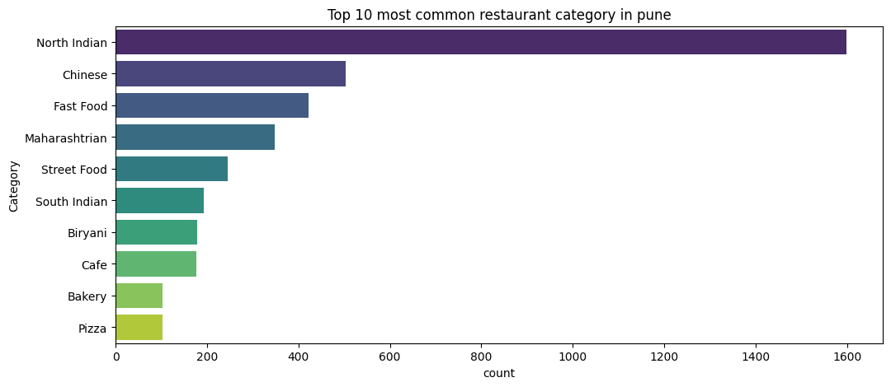

- Price Distribution:
  - Histogram of Pricing_for_2 showed that most restaurants fall within the ₹200–₹800 range.
  - Few high-end outliers charge over ₹2000 for two people.

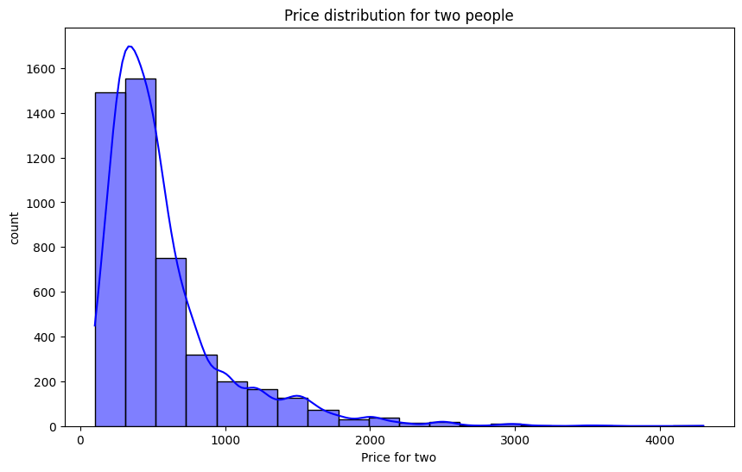

- Dining Rating vs. Price:
  - Scatter plot indicated no strong correlation; expensive restaurants don’t always have better ratings.
  - Some affordable places have high ratings, hinting at value-for-money favorites.

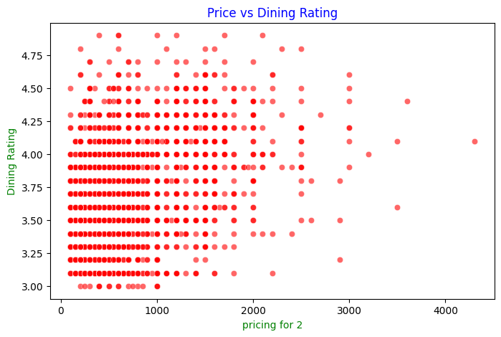

- Known_for1 Word Cloud:
  - Generated a word cloud to understand popular specialties.
  - Terms like Fast Food, Street Food, Desserts, and North Indian stood out.

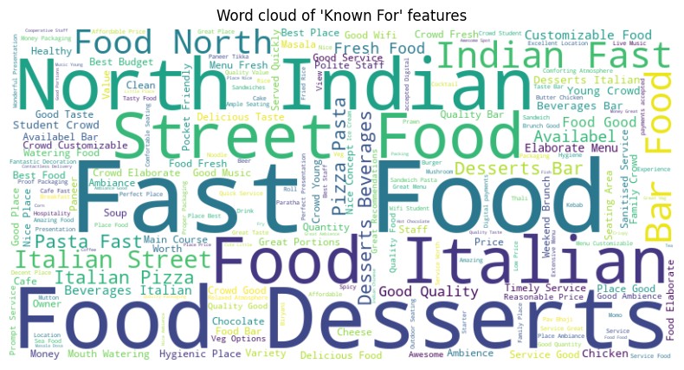

- Votes vs. Rating Analysis:
  - Found a positive correlation between number of votes and rating — highly rated places generally have more reviews.

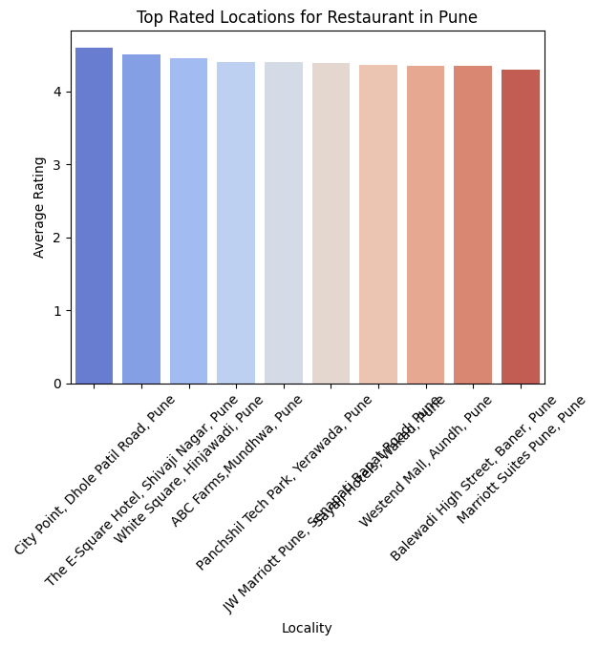

- Restaurant Locations:
  - Bar chart of Location showed hotspots like Kothrud, Viman Nagar, and Koregaon Park.
  - Indicates areas with high density of restaurants.

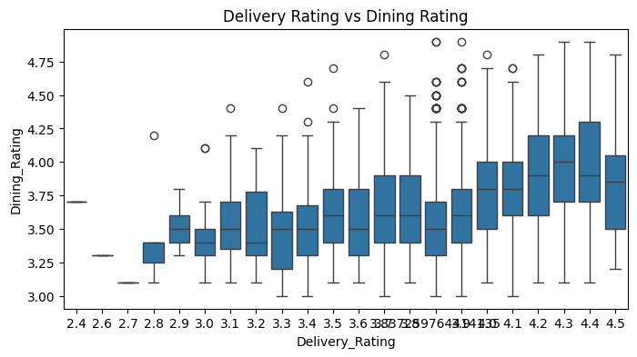

- Chain vs. Non-Chain Restaurants:
  - Compared pricing and rating trends for chain vs. non-chain outlets.
  - Chain restaurants tended to have more consistent pricing and moderate ratings.

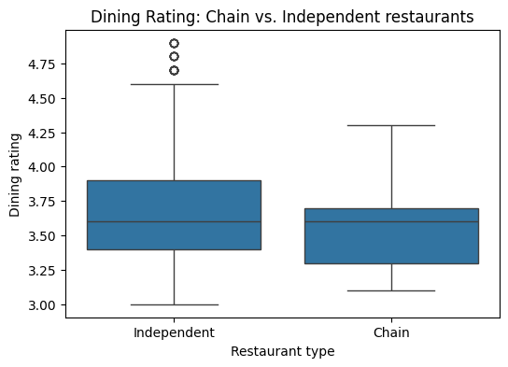

- Best Budget-Friendly Restaurants

- Identified restaurants with Dining Rating ≥ 4.4 and Pricing for Two ≤ Median price to highlight places offering high quality at an affordable price.
- These restaurants represent great value-for-money options and are useful recommendations for budget-conscious diners in Pune.

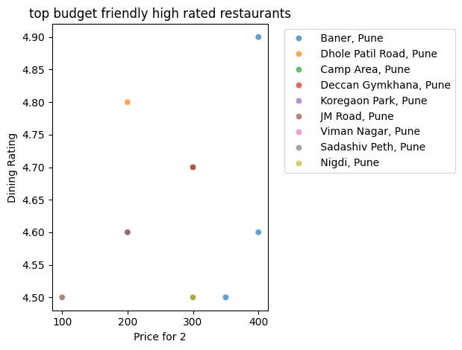

🤖 Machine Learning Analysis
To extract deeper insights and make predictions, both supervised and unsupervised machine learning models were applied to the dataset. Each model was carefully selected based on the nature of the problem and the available features.

🔵 Supervised Learning
1. Linear Regression
- Goal: Predict Dining_Rating based on features like Pricing_for_2, Votes, and Category.
- Steps:
  - Selected relevant features.
  - Encoded categorical variables.
  - Scaled numeric features.
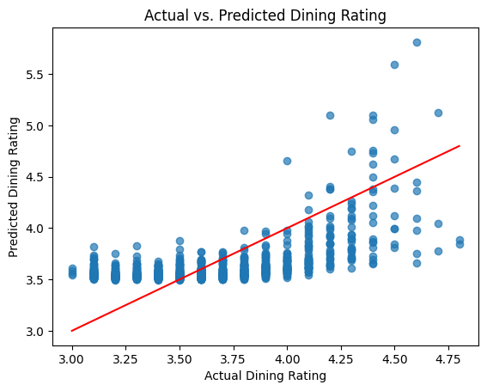
  - Trained a LinearRegression model.
- Result: Achieved a moderate R² score (~0.30–0.50), indicating average predictive power.

🟣 Unsupervised Learning
1. K-Means Clustering
- Goal: Clustering Reataurant based on Location and Price
- Steps:
  - Scaled data.
  - Used Elbow Method to choose optimal clusters.
  - Visualized clusters.

- Insights: KMeans clustering revealed distinct geographic zones in Pune where restaurants share similar pricing patterns, helping to identify premium, mid-range, and budget-friendly areas across the city.

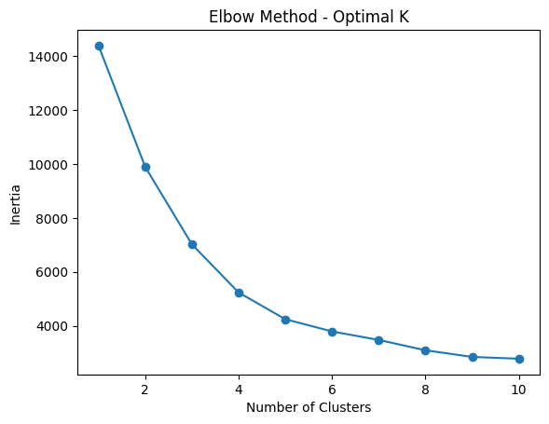

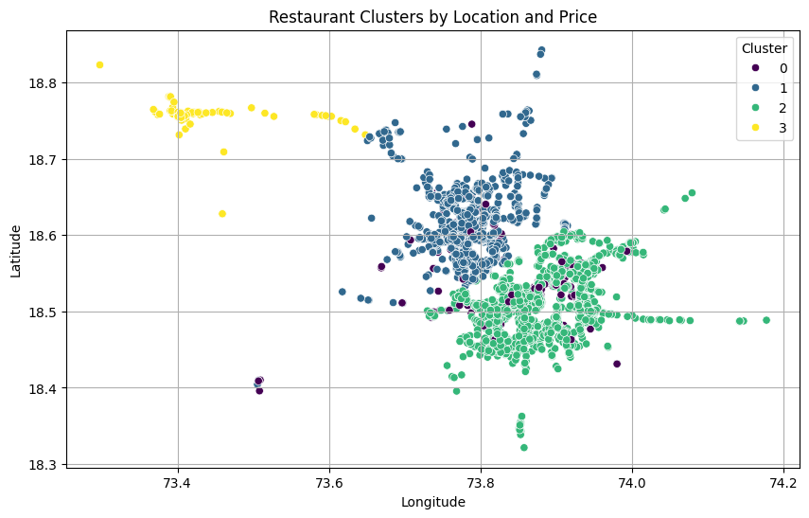

📌 Feature Engineering Highlights
- Text simplification and encoding for Category, Primary_Category.
- Scaling of Pricing_for_2, Votes.
These models provided both predictive insights and business segmentation logic, supporting decisions like pricing, marketing, and expansion strategy.

✅ Conclusion
The Pune Restaurants dataset offers a detailed look into the city’s dynamic food industry, and this project successfully extracted valuable insights using a combination of exploratory data analysis and machine learning.

🎯 Key Takeaways
- Dominant Restaurant Types: Cafes and quick-service restaurants are most common, especially in urban zones like Kothrud and Viman Nagar.
- Price vs. Quality: Higher pricing does not always equate to higher ratings. Some budget-friendly restaurants maintain excellent dining experiences.
- Specialties: Word cloud analysis revealed popular food items and restaurant themes like “Italian”, “Family Friendly”, and “Fast Food”.
- ML Predictions:
  - Linear regression moderately predicted restaurant ratings.
  - Clustering revealed patterns in price and service categories.

📌 Applications
- For Businesses: Optimize pricing, improve customer satisfaction, and identify ideal locations for new outlets.
- For Users: Help food lovers discover hidden gems and better value-for-money restaurants.
- For Data Science: Demonstrates how real-world datasets can be used to train predictive and descriptive models.

